Role Profile

Job Title: Operations Manager (Learning Disabilities)
Responsible to: Head of Operations
Responsible for: Service Manager(s) & Team Leader(s)
Salary: £40,000

Job Purpose

- To provide support to the Care and Support division through service audits and assessments working closely with colleagues to identify and implement areas for improvement so that high quality and compliance with all relevant regulation is ensured.
- To support all divisions of Castell Ventures in the development of the business and the completion and submissions of tenders as well as undertaking audits, assessments and training where required.
- To be responsible for the operational performance of care and support services ensuring the teams enable people to lead fulfilled lives with good overall wellbeing and are provided with the opportunity to maximise their potential.
- To ensure care services comply with and exceed standards set out by the Care Inspectorate Wales and Social Care Wales, doing all you can to make sure people come to no harm and are happy with the level of support they receive.
- Act as the legislative regional Registered Manager.
- To support, manage and be responsible for the care and support team, recruiting and training staff as necessary and provide an out of hours on-call management service on a rotational basis.

Accountabilities

Leadership

- Provide high quality and effective line management to direct reports and teams in the day to day management of care services.
- Assist in the identification and implementation of business solutions, making good ideas happen including taking the lead where required.
- Set an example to all care staff sharing knowledge and skills with the team to establish an ethos of continual improvement and development and shared company values.

Operational

- Undertake assessments and audits of care and support services to ensure they are well run, make best use of resources and are compliant with regulations.
- Identify areas for improvement and provide support to managers to implement changes and monitoring action plans.
- Work in partnership with the Head of PBS and Quality to ensure that Positive Behaviour Support is fully implemented and followed in the delivery of care and support services.
- Keep up to date with developments of care and support policy and share that knowledge with colleagues.
- Provide audit, outcome and compliance reports as necessary with practical and deliverable action plans.
- Recruit staff and provide coaching and mentoring on a continual basis.
- Support the organisation in fulfilling its Safeguarding responsibilities and complete investigations.
- Ensure prompt investigation of complaints.
- Monitor incident and accidents for trends and action; complete safeguarding and CIW notifications as necessary.
- Ensure that all records are completed in a timely manner and are accurately maintained in accordance with contracts and regulations.
- Establish and maintain systems to support service delivery, service expenditure, invoicing and accountability to funders and stakeholders.
- Ensure person centered services are delivered.
- Provide compliant, quality services that deliver measurable outcomes.
- Monitor the delivery and effectiveness of services through observation of staff performance and identify areas of individual and collective professional development.
- Support managers to manage the assessment and preparation of people’s commencement and cessation of services.
- Manage the services in accordance with standards agreed with senior management, legislative requirements, relevant regulations, and in line with accepted best practices.

Strategic

- Develop policy and procedures that support models of innovation and best practice and ensure they are implemented, adhered to and complied with.
- Evaluate and report on the service; share business development opportunities and support in the development of new services in response to local demand.
- Develop and maintain positive relationships built on trust with external stakeholders and commissioners and positively promote the organisation at all times.
- Actively promote the services offered as a market leader and ensure services are effectively marketed.

General

The above responsibilities should be read in conjunction with the express contractual terms illustrated in the Staff Handbook and other non-contractual Policies and Procedures published by Castell, which are amended from time to time.

In addition to the specified Job Purpose and Accountabilities all staff are expected:

- To proactively promote the principles and practices of equality of opportunity, to ensure its effective implementation within their own work and the work of team members, as appropriate and to abide by and support the Castell’s Equal Opportunities Policy as an integral part of all duties.
- To understand their personal responsibilities for ensuring the highest standard of Health and Safety towards themselves and others (e.g. colleagues, team members, customers, the public, etc.). Castell’s Health and Safety Policies detail relevant responsibilities for employees, managers and senior staff members as well as the consequences for failing to follow them.
- To undertake any other duties requested by the Line Manager, which are consistent with the overall purpose of the post.

Knowledge/Skills/Experience

Essential

- A commitment to working according to the organisations values and operating principles.
- Experience of managing care and support services for adults who have learning disabilities, Autism and complex behavioural needs including supported living.
- Experience of working across multiple services.
- Be a Registered Manager with Social Care Wales or have the qualifications to enable registration.
- NVQ 4 in both "Care" and "Management" or diploma level 5 in leadership for health and social care.
- Strong management skills and the ability to lead a team.
- Strong written and verbal communication and ICT skills.
- Good research skills including the ability to write or to annotate reports and policy and procedure.
- Experience of collaborative working with both internal and external stakeholders.
- Self-motivation, to work on your own and the ability to multi-task and prioritise.
- A discrete, sensitive and compassionate approach.
- Full drivers licence and access to own vehicle.

Desirable

- Training qualification and completion of trained trainer courses pertinent to the care.
- Ability to speak and understand and read and write the Welsh language.

Our Philosophy of Care

We created Castell to support some of the most amazing people by giving them tailored, innovative and outstanding care and support services. We pride ourselves on the meaningful relationships we develop with people and their families, and how our approach makes a real difference. Our Philosophy of Care is:

‘to empower and enable people to live as fulfilling and independent a life as possible while having their needs met through outstanding services that support them to achieve their aspirations and celebrate them as a person’.

Our Values

Every organisation has a culture and we are very deliberate in shaping ours, setting a clear vision to make a difference, whilst driving integrity in everything we do and always taking action to do the right thing. Our world revolves around people; so, the behaviours we use when we engage with people are naturally a central part of our culture. We aim for integrity in everything we do, having strong, visible values which we strive to live out in the day-to-day management of the business and delivery of services. We truly believe in these values, and this naturally affects how we behave.
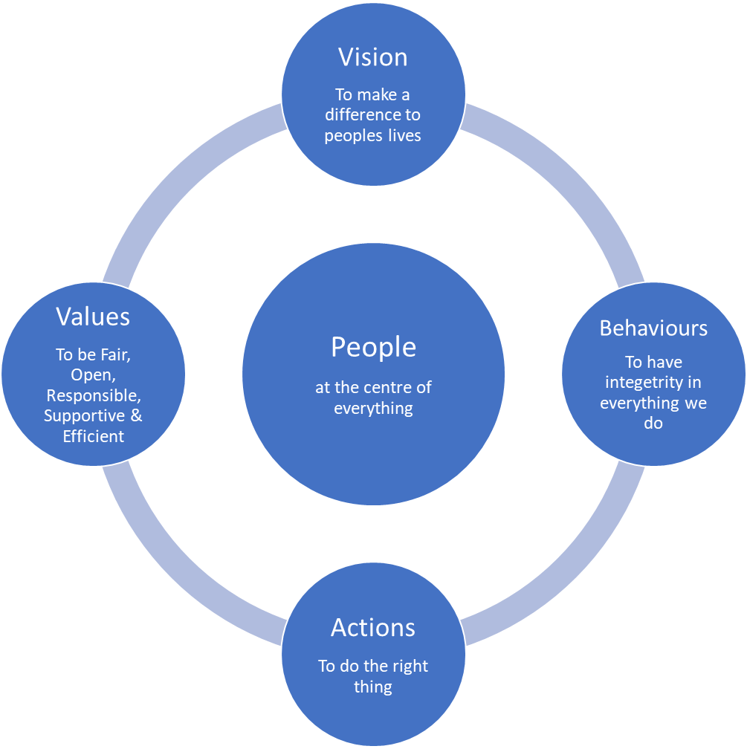

Our operating principles

We may know our vision and behave with integrity driven by a belief in our values, but to maximise our impact for staff and customers it is crucial that we do the right thing. Our operating principle is to review based upon the cycle of Know, Understand and Improve. Firstly, to know the reality of what customers need and what service delivery is really like from a customer’s perspective. Secondly, to understand the underlying reasons for this and for problems which need solving to achieve our vision. Thirdly, to improve things, always checking that improvements have the intended effects and that performance can be measured.

